**Структура Базы данных.**

**Таблица Purchase:**

|  |  |
| --- | --- |
| **Название поля** | **Тип поля** |
| Id | AutoField |
| PurchaseOrder | CharField |
| RegistryNumber | CharField |
| ProcurementMethod | CharField |
| PurchaseName | CharField |
| AuctionSubject | CharField |
| PurchaseIdentificationCode | CharField |
| LotNumber | IntegerField |
| LotName | CharField |
| InitialMaxContractPrice | FloatField |
| Currency | CharField |
| InitialMaxContractPriceInCurrency | FloatField |
| ContractCurrency | CharField |
| OKDPClassification | CharField |
| OKPDClassification | CharField |
| OKPD2Classification | CharField |
| PositionCode | CharField |
| CustomerName | CharField |
| ProcurementOrganization | CharField |
| PlacementDate | DateField |
| UpdateDate | DateField |
| ProcurementStage | CharField |
| ProcurementFeatures | CharField |
| ApplicationStartDate | DateField |
| ApplicationEndDate | DateField |
| AuctionDate | DateField |
| notification_link | CharField |
| quantity_units | IntegerField |
| nmck_per_unit | FloatField |
| nmck_file | CharField |
| protocol_file | CharField |
| TKPData | CharField |
| QueryCount | IntegerField |
| ResponseCount | IntegerField |
| AveragePrice | FloatField |
| MinPrice | FloatField |
| MaxPrice | FloatField |
| StandardDeviation | FloatField |
| CoefficientOfVariation | FloatField |
| NMCKMarket | FloatField |
| FinancingLimit | FloatField |
| PurchaseStatus | CharField |
| InitialMaxContractPriceOld | FloatField |
| NMCK_1 | CharField |
| ContractCount | IntegerField |
| NMCK_2 | CharField |
| NMCK_3 | CharField |
| NMC_determ | FloatField |
| NMC_coef_determ | FloatField |
| organization_name | CharField |
| organization_price | CharField |
| organization_name_date | CharField |
| organization_name_file | CharField |
| method_direction_requests | CharField |
| method_usage_information | CharField |
| nmc_various_methods | CharField |
| nmc_cost_method | CharField |
| comparable_product_price | CharField |
| nmc_two_methods | CharField |
| file_4 | CharField |
| isChanged | BooleanField |

**Таблица Contract:**

|  |  |
| --- | --- |
| **Название поля** | **Тип поля** |
| Id | AutoField |
| TotalApplications | CharField |
| AdmittedApplications | CharField |
| RejectedApplications | CharField |
| PriceProposal | CharField |
| Applicant | CharField |
| Applicant_satatus | CharField |
| WinnerExecutor | CharField |
| ContractingAuthority | CharField |
| ContractIdentifier | CharField |
| RegistryNumber | CharField |
| ContractNumber | CharField |
| StartDate | DateField |
| EndDate | DateField |
| ContractPrice | CharField |
| AdvancePayment | FloatField |
| ReductionNMC | FloatField |
| ReductionNMCPercent | FloatField |
| SupplierProtocol | CharField |
| ContractFile | CharField |
| purchase | ForeignKeyField |

**Таблица FinalDetermination:**

|  |  |
| --- | --- |
| **Название поля** | **Тип поля** |
| Id | AutoField |
| RequestMethod | CharField |
| PublicInformationMethod | CharField |
| NMCObtainedMethods | CharField |
| CostMethodNMC | CharField |
| ComparablePrice | CharField |
| NMCMethodsTwo | CharField |
| CEIComparablePrices | CharField |
| CEICostMethod | CharField |
| CEIMethodsTwo | CharField |
| purchase | ForeignKeyField |

**Таблица CurrencyRate:**

|  |  |
| --- | --- |
| **Название поля** | **Тип поля** |
| Id | AutoField |
| CurrencyValue | FloatField |
| CurrentCurrency | CharField |
| DateValueChanged | DateField |
| CurrencyRateDate | DateField |
| PreviousCurrency | CharField |
| purchase | ForeignKeyField |
| isChanged | BooleanField |

**Таблица User:**

|  |  |
| --- | --- |
| **Название поля** | **Тип поля** |
| id | AutoField |
| username | CharField |
| password | CharField |

**Таблица Role:**

|  |  |
| --- | --- |
| **Название поля** | **Тип поля** |
| id | AutoField |
| name | CharField |

**Таблица UserRole:**

|  |  |
| --- | --- |
| **Название поля** | **Тип поля** |
| id | AutoField |
| user | ForeignKeyField |
| role | ForeignKeyField |

**Таблица UserLog:**

|  |  |
| --- | --- |
| **Название поля** | **Тип поля** |
| Id | AutoField |
| username | CharField |
| login_time | DateTimeField |
| logout_time | DateTimeField |

**Таблица ChangedDate:**

|  |  |
| --- | --- |
| **Название поля** | **Тип поля** |
| id | AutoField |
| RegistryNumber | CharField |
| username | CharField |
| chenged_time | DateTimeField |
| PurchaseName | CharField |
| Role | CharField |
| Type | CharField |

**ER диаграмма.**

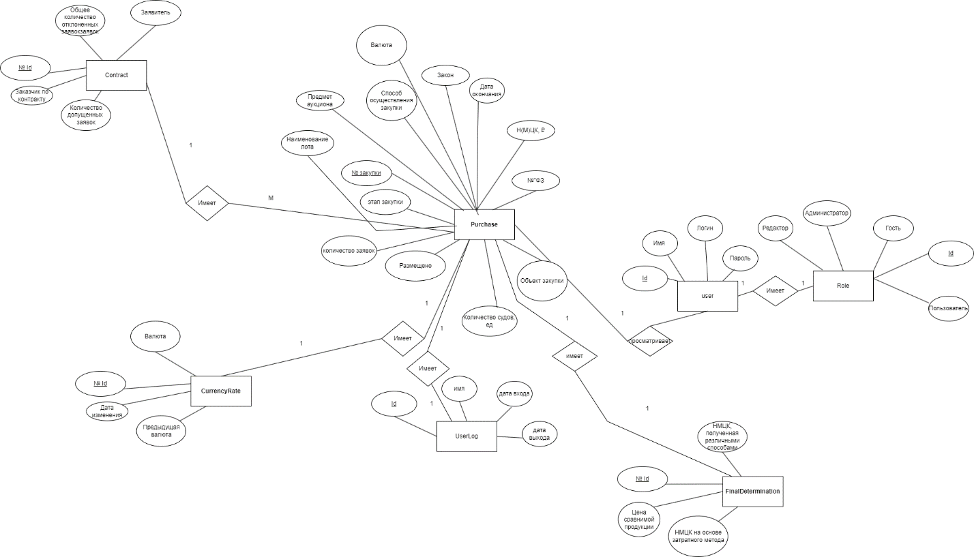

**Диаграмма архитектуры приложения**

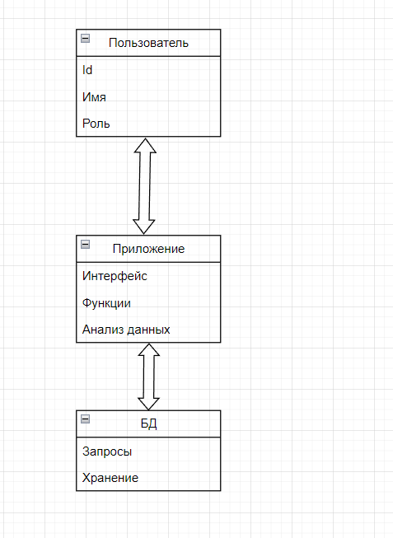

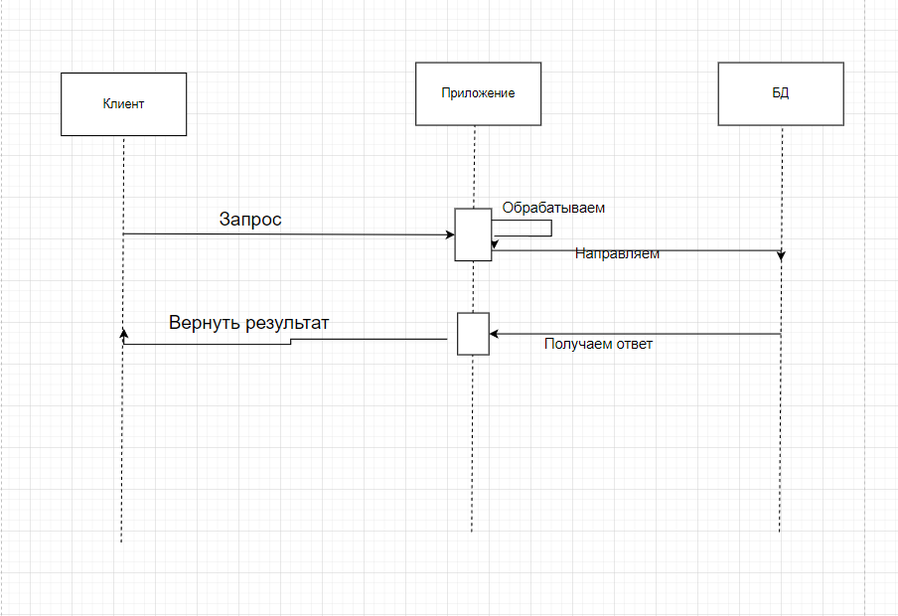

**Таблица ролей**

|  |  |  |  |  |  |  |
| --- | --- | --- | --- | --- | --- | --- |
| Роль | Просмотр БД | Использование фильтров | Загрузка данных в БД | Выгрузка Данных из БД | Редактирование БД | Управление пользователями,  БД |
| Администратор | Да | Да | Да | Да | Да | Да |
| Редактор | Да | Да | Да | Да | Да | Нет |
| Пользователь | Да | Да | Нет | Да | Нет | Нет |
| Гость | Да | Да | Нет | Нет | Нет | Нет |